“Um das Herz zu Wärmen”
Musical Gems of German Classical, Opera and Song
“to Warm the Heart”
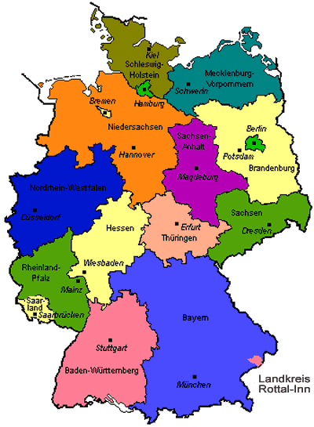
Rosanne Hargrave soprano Michele Boretti flute Michael Clement piano

Sunday, February 21, , 2016 @ 2:30 pm
Schenectady Library’s “Beat the Snow Concert Series”
McChesney Room
99 Clinton Street, Schenectady NY

Featuring such composers as Bach, Mozart, Wolf, Brahms, Korngold, Mackay, Lehar and Strauss with gems from Passions of St John and St Matthew, Die Fledermaus, The Merry Widow and Queen of the Night !

